Homework 4

Q 1.1

Given two views, we can use fundamental matrix to capture the relationship between the corresponding points. The equation is as follows:

$$x_{l}^{T}Fx_{r}=0$$

Where F is the fundamental matrix with 9 elements, and the $f_{33}$ is 1 when the origin is the intersection of the light ray through the image planar.

$$F=\left[\begin{matrix}f_{11} & f_{12} & f_{13} \\ f_{21} & f_{22} & f_{23} \\ f_{31} & f_{32} & f_{33}\end{matrix}\right]$$

$${\left[\begin{aligned}x_{i} \\ x_{i} \\ 1\end{aligned}\right]}^{T}\left[\begin{matrix}f_{11} & f_{12} & f_{13} \\ f_{21} & f_{22} & f_{23} \\ f_{31} & f_{32} & f_{33}\end{matrix}\right]\left[\begin{aligned}{x'}_{i} \\ {y'}_{i} \\ 1\end{aligned}\right]=0$$

The origin of image plane is [0 0 1]’, so the result is:

$$\left[\begin{matrix}f_{11} & f_{12} & f_{13} \\ f_{21} & f_{22} & f_{23} \\ f_{31} & f_{32} & f_{33}\end{matrix}\right]\left[\begin{aligned}0 \\ 0 \\ 1\end{aligned}\right]=0$$

Then $f_{33}=0;$

Q 1.2

$F=K^{-T}EK^{-1}=K^{-T}RTK^{-1}$, we can eliminate the rotation matrix R since there is only pure translation along the x axis, then the tx=1, so we can get T as:

$F\sim T=\left[\begin{matrix}0 & 0 & 0 \\ 0 & 0 & -tx \\ 0 & tx & 0\end{matrix}\right]=$ $\left[\begin{matrix}0 & 0 & 0 \\ 0 & 0 & -1 \\ 0 & 1 & 0\end{matrix}\right]$

Using this fundamental matrix F, we can get epipolar line as:

$$l_{2}=FX_{1}=\left[\begin{matrix}0 & 0 & 0 \\ 0 & 0 & -1 \\ 0 & 1 & 0\end{matrix}\right]\left[\begin{matrix}x_{1} \\ y_{1} \\ 1\end{matrix}\right]$$

All the x and x’ locate in one line, since y and y’ are equal. Therefore, the epipole line both parallel to the x axis.

Q 1.3

$$E=R_{rel}∙t_{rel}$$

$$F=K^{-T}∙R_{rel}∙t_{rel}∙K^{-1}$$

Q 1.4



$$F=K^{-T}EK^{-1}=K^{-T}RTK^{-1}\sim T=\left[\begin{matrix}0 & -tz & ty \\ tz & 0 & -tx \\ -ty & tx & 0\end{matrix}\right]$$

According to the figure, the camera C and C’ has a pure translation without rotation, also they have the same intrinsic matrix. Thus, their fundamental matrix can be related to a skew-symmetric matrix.

We can imagine there is a virtual camera right side of the mirror, so we can use projective matrix to build up relationship:

$$p_{1}=C_{1}P;p_{1}'=C_{1}P';p_{2}=C_{2}P;p_{2}'=C_{2}P'$$

and:

$$p_{2}Fp_{1}^{'}=0;p_{2}'Fp_{1}=0;p_{1}F^{T}p_{2}^{'}=0; p_{1}'Fp_{2}=0;$$

Using above equations, we can build up a constraint:

$$p_{1}^{'}Fp_{2}+p_{2}Fp_{1}^{'}=0$$

$${(M}_{1}TP)\left(F^{T}+F\right)\left(M_{1}TP\right)=0$$

Because $M_{1}TP$ cannot be zero, $F^{T}=-F$. Thus this fundamental matrix F is the skew-symmetric matrix.

Q 2.1

F =

0.0000 0.0000 -0.0030

0.0000 -0.0000 -0.0000

0.0028 -0.0000 0.0148

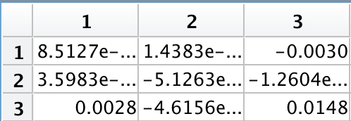

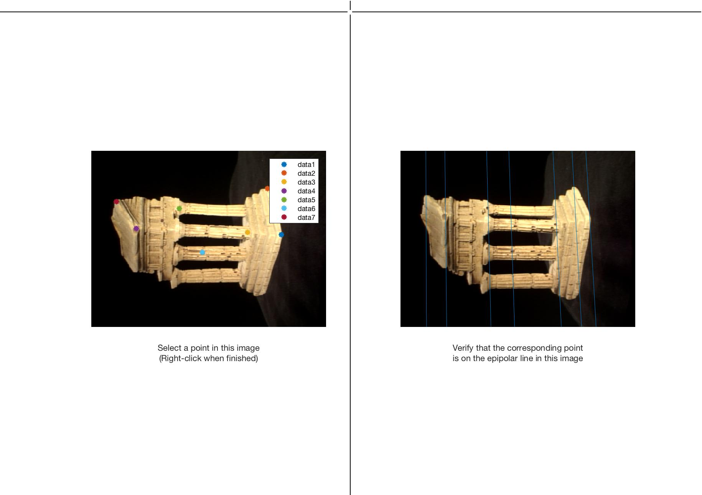

Q 2.2

F =

0.0000 -0.0000 0.0071

-0.0000 0.0000 0.0002

-0.0064 0.0002 -0.2181

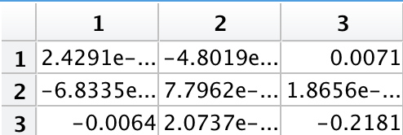

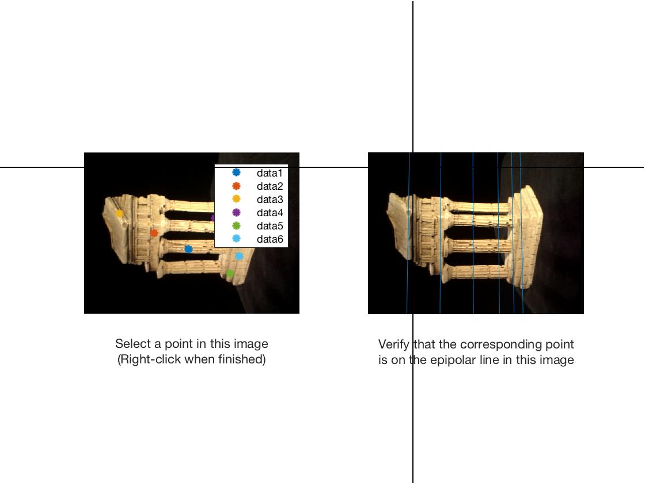

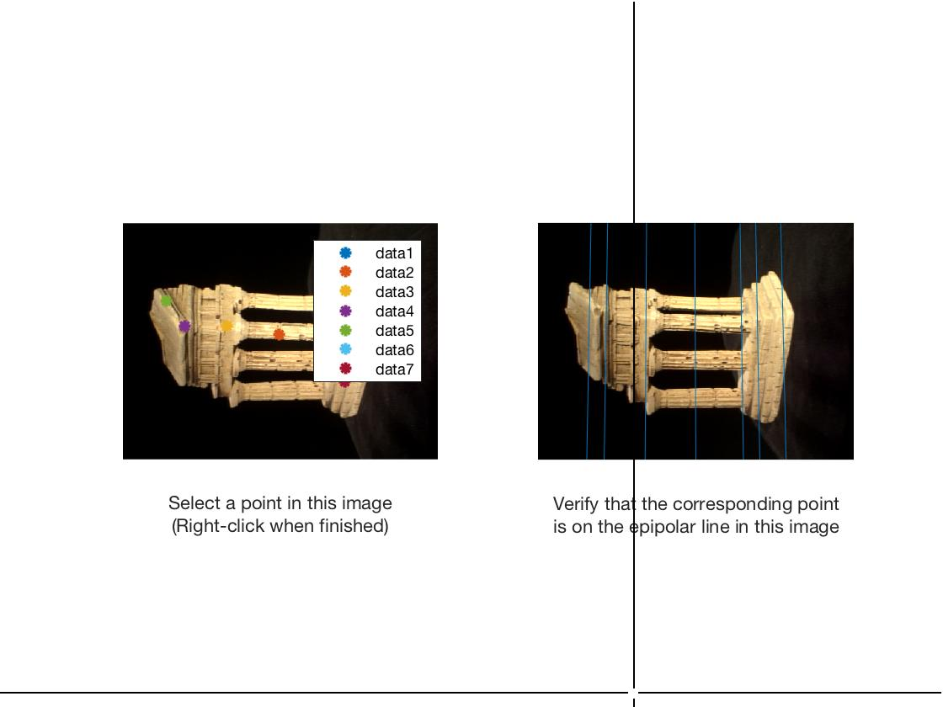

Q 3.2

$$AP=0$$

$$A=\left[\begin{matrix}x_{1}C_{13}-C_{11} \\ y_{1}C_{13}-C_{12} \\ x_{2}C_{23}-C_{21} \\ x_{2}C_{23}-C_{22}\end{matrix}\right]$$

Where ${(x}_{i},y_{i})$ is the coordinate of point from camera $i$; $C_{ij}$ is the projective matrix of camera $i$; $j$ is the number of row vector in the $C_{ij}$ projective matrix.

Q 4.1

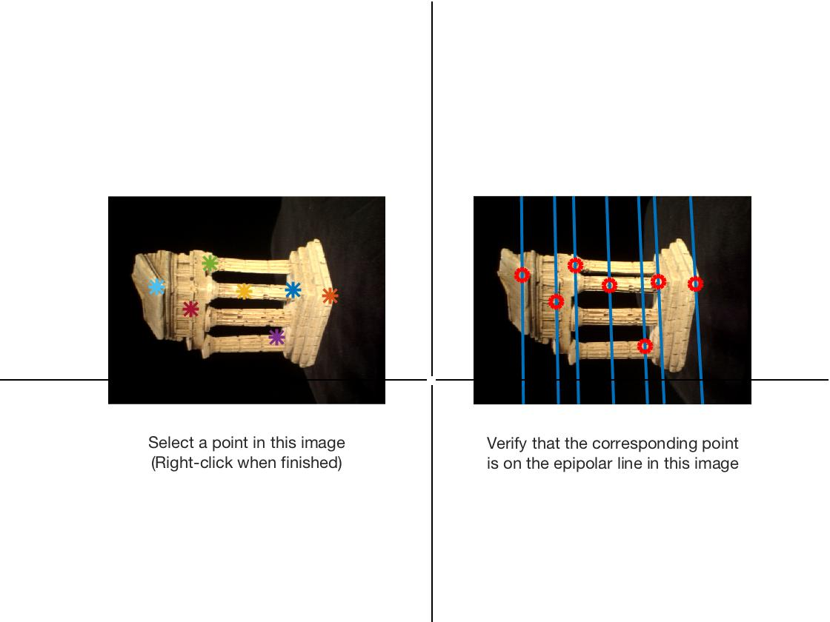

Q 4.2

